PROJECT DOCUMENTATION
HIGHLIGHT REPORT

PROJECT: External Access 2.0
Date: 10 November 2014
Reporting
Period: to 10 November 2014
Author: Bnahu Shrestha
Approved: Naoto Yamamoto – 10/November/2014

1. Status Summary
The project is currently at initiation stage. MCT has lead the start up and initiation stages of the project, PID is formulated, which is expected to be approved in a board meeting to take place week of November 10.

Based on PID, the following work components are identified:
- Component and UI Design
- FIM implementation
- Application Integration Platform
- Data& Reporting
- Integration and UI Build
- Initial Roll Out and Stabilization

Project Sponsor is Jens Wandel (BOM) and Jorge Chediek (BRA). Shirin Hamid (OIST) is senior supplier. PID designates Carlos Arboleda as the project manager a.i.

For the board meeting, the following initial timeframe will be tabled:

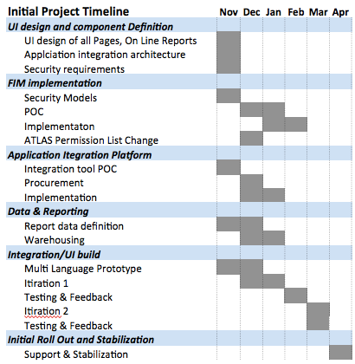

2.This Reporting Period:
Project is at initiation stage. The board meeting and approval of PID is expected to set project stages and corresponding reporting period

3. Next Reporting Period
The 1st work package is expected to deliver a design document outlining details of each components to set expectations across the team before build initiate later this year. This phase will engage consultants to document requirements, architect solutions. As a part of the phase, proof of concept of integration tools, as well as initiation of purchasing the integration tool is expected to take place.

8. Project Stage Tolerance
Total of 250,000 is expected to be allocated to fund activities associated with this stage and to the end of this year. The breakdown is the following:
- 80,0000 for FIM Authentication architecture component
- 30,000 for procurement of integration tools
- 35,000 for solutions architecture
- 105,000 for solutions development

9. Request for Change
None

10. Key Issues and Risks
The solution requires overhaul of authentication layer, reporting layer, as well as application integration layer. This involves technical risks, which will need to be re-assessed once the detail design is tabled at the end of this stage.

